*CST 238: Graphical User Interfaces*

**Puzzle 6 - Multimedia Memory Management**

During puzzle 6 you will demonstrate your learning of concepts related to the camera device and memory management in QML. For more information see the material from lectures:

<https://github.com/StewartTaylor/CST-238/tree/master/Lectures/Week%206/lecture%202>

<https://github.com/StewartTaylor/CST-238/tree/master/Lectures/Week%205/Lecture%201>

Also if at any point you are confused about how an object works - remember to utilize the documentation. Furthermore, seek out examples and find the code you need. Google can help.

You have been provided boilerplate code found at  
<https://github.com/StewartTaylor/CST-238/tree/master/Puzzles/Week%206>

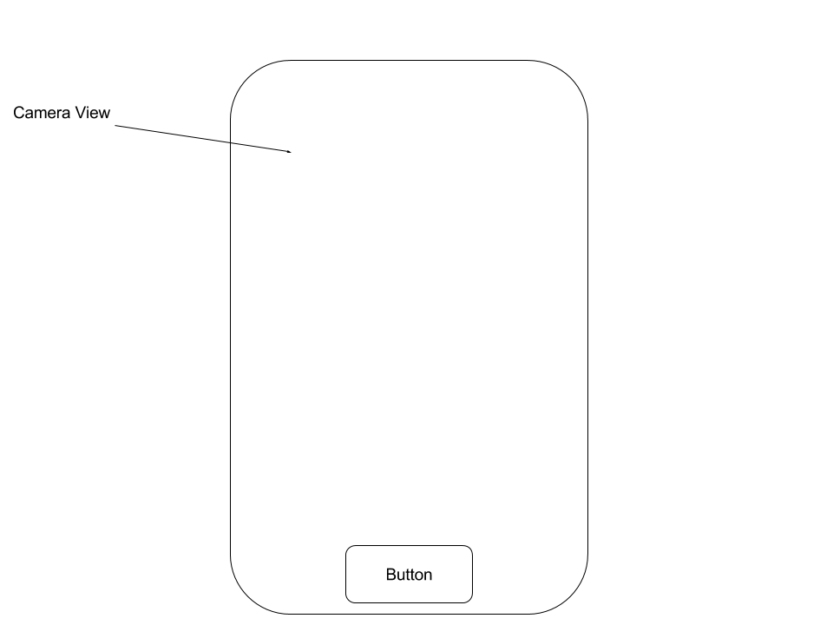

Extend the boilerplate code to include the 3 changes found below:

* **Modify the CameraDialog to “load” the camera object after it becomes *visible*. (Use a *Loader)***
* **Alter the cameraViewfinder to display “No camera available” instead of the preview if the computer system does not have a camera.**
* **Add a button to capture an image and then save the image to a file.**

Add one **unique** thing that fits into the application (creativity is encouraged).

Use your existing code, examples you have found, and other code resources to save time. This puzzle should take 50 or less minutes but you have until the end of week 9 to get it checked off.

**Resources:**

Dynamic Object Creation JS

<http://doc.qt.io/qt-5/qtqml-javascript-dynamicobjectcreation.html>

Qt/Qml Signals

<http://doc.qt.io/qt-5/qtqml-syntax-signals.html>